1. 
2. Working on a large multi module project can affect performance, since intelligence needs to process a large number of flies for search inspections, refactoring code and similar operations. When you’re busy coding and want nothing to disturb your creative flow.  
   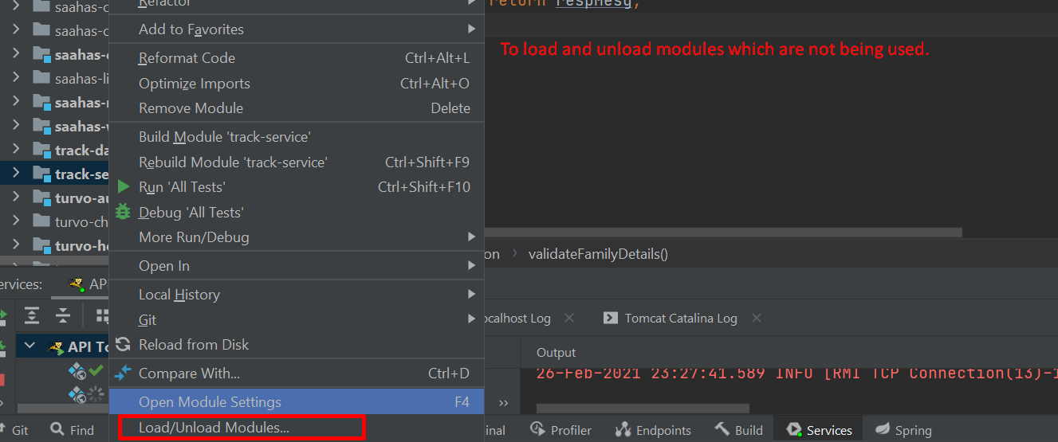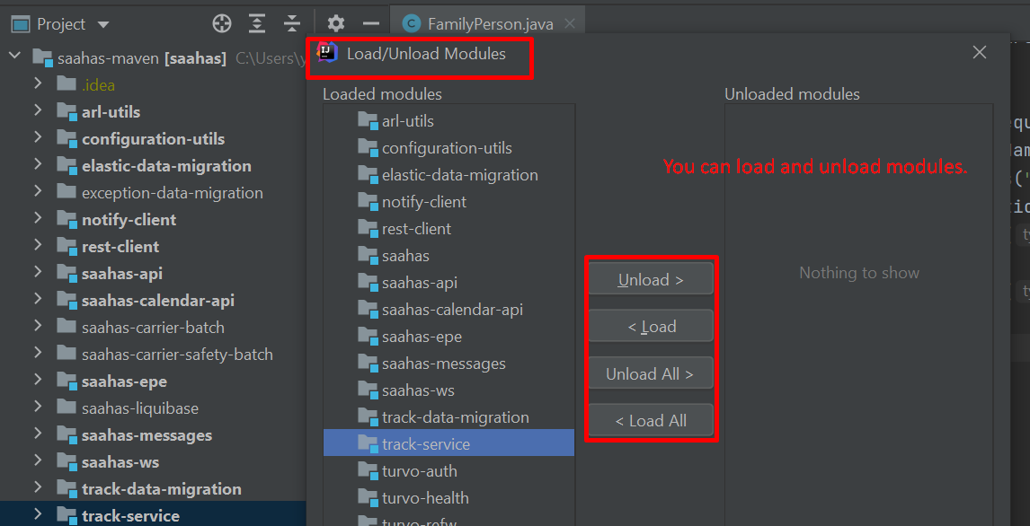



1. **Plugin Analysis**:  
   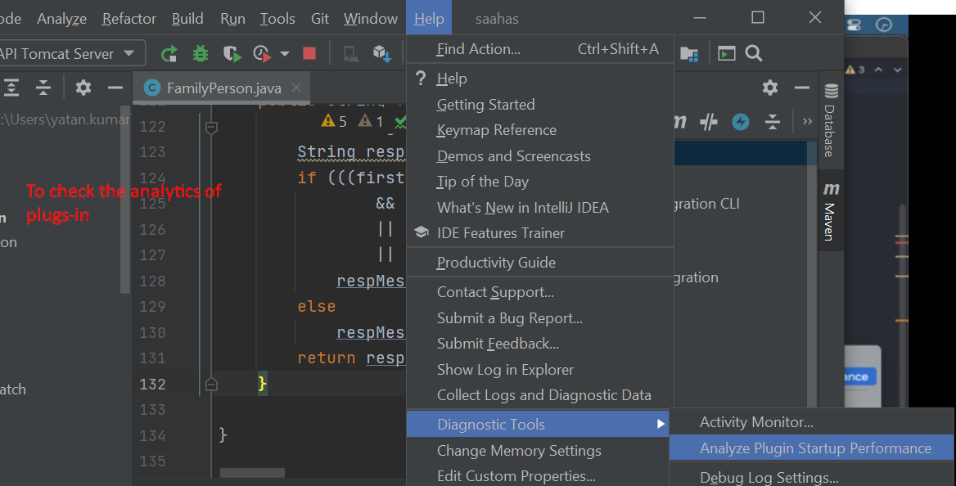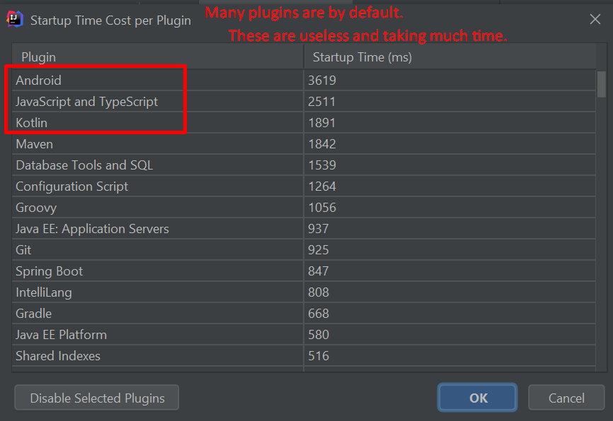
2. 
3. Not Clear